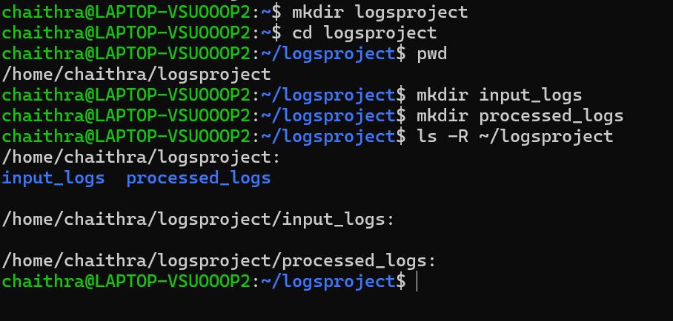
1.Create a directory named LogsProject inside your home directory. Inside it, create two subdirectories named input_logs and processed_logs.

The mkdir command is used to create a new directory (folder) in your current location or at a specified path. LogsProject is created using this command and inside this directory other two files named input_logs and processed logs are created. cd (Change Directory) The cd command allows you to move from your current directory to another. You can use it with relative paths (e.g., cd folder) or absolute paths (e.g., cd /home/user/folder) to navigate the file system. pwd (Print Working Directory) The pwd command shows the full path of your current working directory. ls -R (List Recursively) The ls -R command lists all files and directories recursively, meaning it shows the contents of the current directory and all its subdirectories. It helps when you want to see the entire folder structure starting from your current location.

2.Inside the input_logs directory, create three text files using touch: server1.log, server2.log, and readme.txt. Add some dummy content to these files using echo, ensuring that server1.log and server2.log contain at least five lines each with a few lines containing the word “error” in different cases (like Error, ERROR, error).

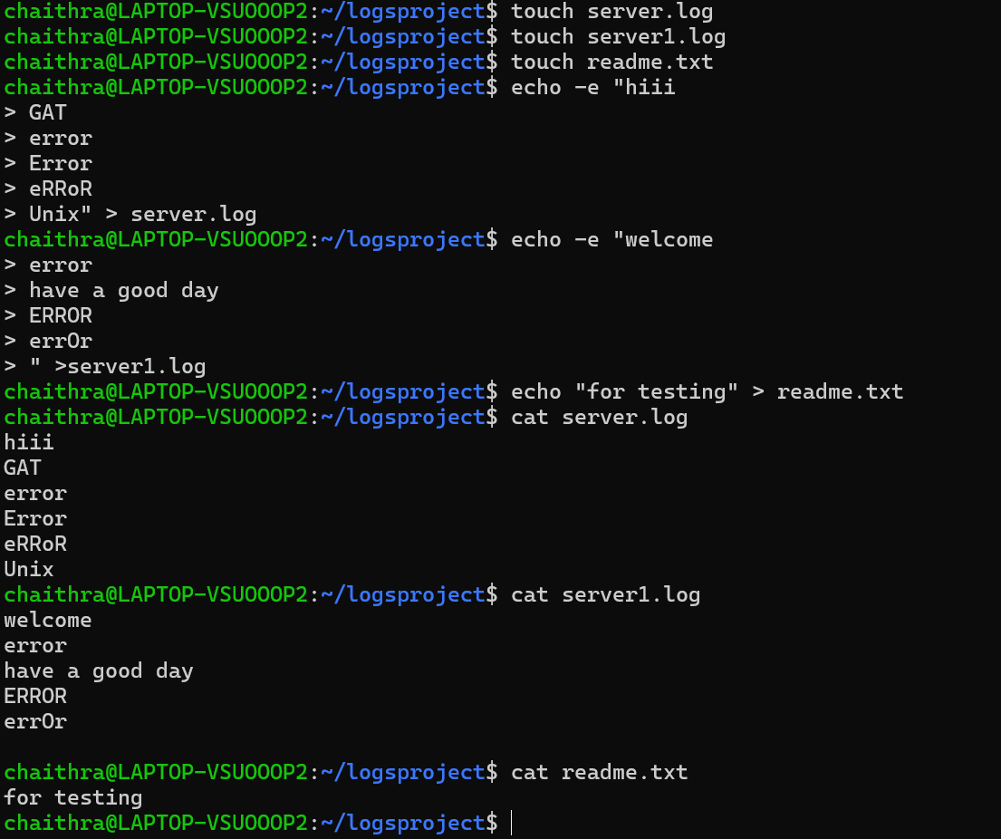
Touch-The touch command is used to create an empty file or update the timestamp of an existing file. For example, touch server1.log creates a new file named server1.log if it doesn't exist. Hence by using touch three files server1.log, server2.log, readme.txt are created. Echo-The echo command displays a line of text or variables to the terminal. It’s often used to show messages or write text into files. Example: echo "Error" > server1.log writes "Hello" into a file. cat (Concatenate)-The cat command is used to display the contents of a file or combine multiple files. For example, cat server1.log prints the file's content, and cat server1.log server2.log > combined.log merges two files.
3.List all files in the input_logs directory using ls and filter only .log files using grep.

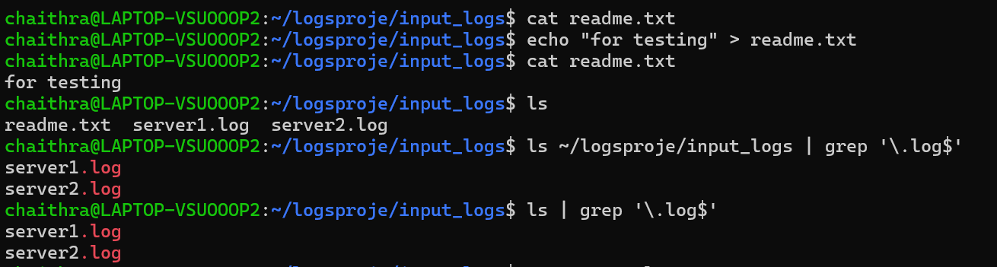

The ls command is used to list files and directories in the current working directory. The grep command is used to search for specific text patterns within files or output. It returns lines that match the pattern and is very useful for filtering content. Here the grep command is used to get the fines containing log in their name’s. so, the server1.log and server2.log files are shown on the output.

4.Count the number of lines and words in server1.log using wc, and display the lines that contain the word “error” using grep -i.

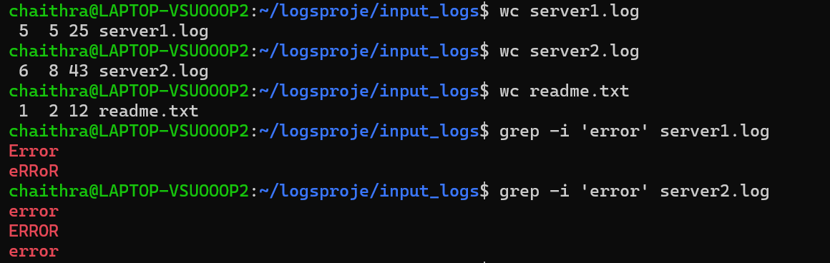

wc (Word Count)-The wc command is used to count lines, words, and characters in a file. By default, it shows all three counts, but you can use options like -l (lines), -w (words), or -c (characters). grep -i (Case-Insensitive Search) - The -i option with grep makes the search case-insensitive. It matches patterns regardless of letter case (e.g., "error", "ERROR", and "ErrOr" all match). As it is case insensitive it prints the lines containing the specific word called error

5.Copy both log files from input_logs to processed_logs, then delete the readme.txt file from input_logs.

cp (Copy)-The cp command is used to copy files or directories from one location to another. You can use it with options like -r to copy directories recursively. Here the files from input_logs are get copied to processed_logs. ls shows the files present in processed_logs .rm (Remove)-The rm command is used to delete files or directories permanently.
Use -r to remove directories and their contents, and -f to force deletion without confirmation. Files deleted with rm do not go to a "Recycle Bin"— they are gone immediately.

6.In processed_logs, append the current date and time (formatted as dd-mm-yyyy HH:MM) to the end of both log files. Use date and redirection operators to do this.

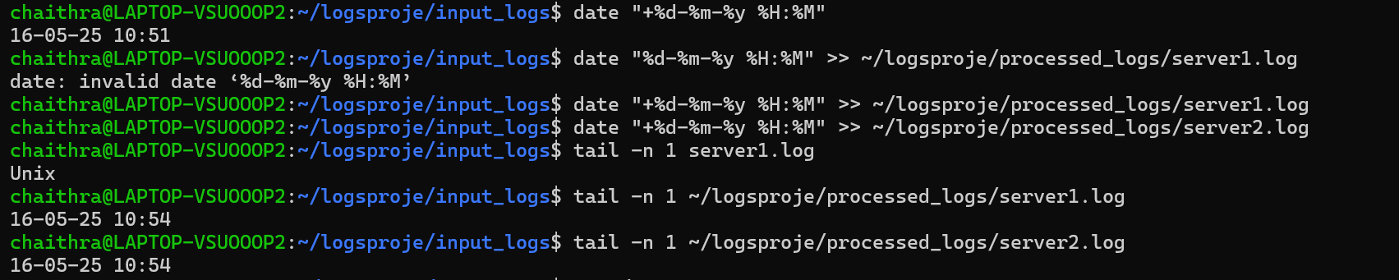

Date-The date command is used to display the current date and time in your system. You can also format the output or set the system date/time. The date is appended to the last line of the server log files .tail-The tail command is used to display the last few lines of a file, by default the last 10 lines. You can use -n to specify how many lines you want to see, or -f to watch a file in real-time (useful for logs). Here n-1 used so as get the last line of the file.

7.Finally, navigate back to the LogsProject directory, display today’s calendar using cal, and print “Log processing complete” on the terminal.

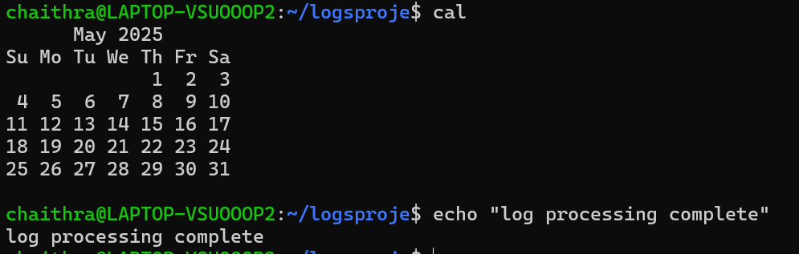
cal (Calendar)
The cal command is used to display a calendar in the terminal. By default, it shows the calendar for the current month, but you can also specify a month and year. Cd command is used to change the directory, and the echo command is used to print the completion message.

